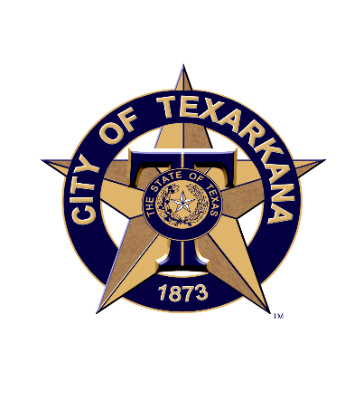

**June 23, 2020**

**There is still time to Complete the 2020 Census**

For Immediate Release:

You still have a few months to complete your U.S. census form, but don’t wait!

The census is conducted every 10 years and aims to count every person in the U.S. Texarkana residents were doing OK, but there’s still a long way to get to a complete count.

According to information available at [2020Census.gov](http://2020census.gov/), just more than 55% of Texas residents had completed the form as this week, falling short of the national rate of nearly 61%. The response rate in Texarkana was 55%. But it should be better.

We know we sound like a broken record on this, but the importance of a complete count is even more crucial in 2020. This is because:

The response in each state, county, and city is used to determine the distribution of billions of dollars in federal funding each year across the nation. An undercount would mean less money for health care, education, and nutrition, as well as other local needs like fire departments, roads, housing, and others. With the unknown long-term impact of the pandemic and high unemployment, it is important we get our fair share of federal funds.

Census counts also help determine:

The number of seats the state is allotted in the U.S. House of Representatives.

If state and local legislative districts need to be adjusted or redrawn.

Census data also can be valuable to business owners who might use it to determine where to open new stores, restaurants, offices or other business operations based on population growth and trends, and understand what services they need to offer.

Answers provided in the census are used only to produce data about our nation and never used against you. The U.S. Census Bureau is bound by law to keep the information you provide confidential. It is prevented from releasing any of your personal information to law enforcement, and government agencies are not allowed to use the information you provide on the census against you and answers will not impact eligibility to receive government benefits.

Let’s make an impact, by making sure everyone gets counted, so our community can have the resources it needs.

**Complete Yours Today!**

Completing the census is easier than ever, for the first time households have been encouraged to respond digitally. Visit [my2020census.gov](http://my2020census.gov/) to fill out the form online.

For help responding to the census, customer service representatives are available every day.

English: (844) 330-2020

Spanish: (844) 468-2020

###